No | TC1
Function | Register
Input | Register as a new user
Scenario | - Sign In  - Create Account  - Register
Result | OK / Not OK
Capture | Click Sign In    Input Email for register, then hit Create an account  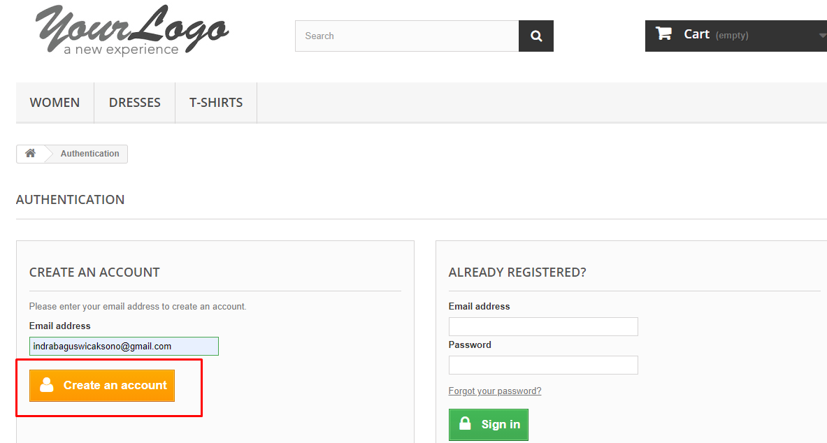  Fill up all form, then hit Register    Register Successfully  

No | TC2
Function | Register
Input | Blank up all primary form
Scenario | - Sign In  - Create Account  - Register
Result | OK / Not OK
Capture | Click Sign in  Input email for register, then hit create an account  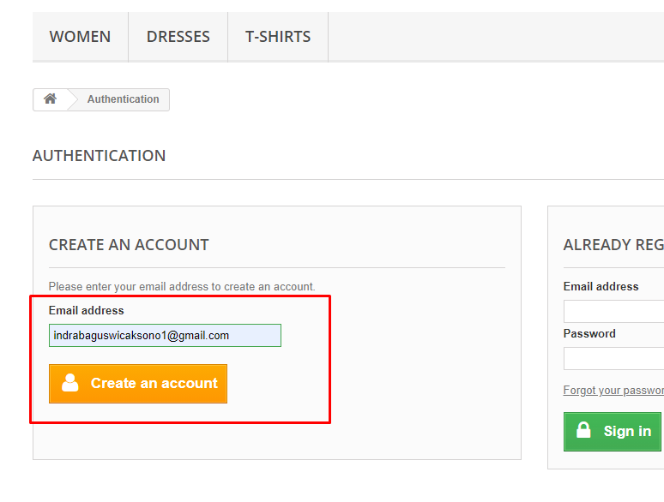  Blank up all mandatory forms, then hit register  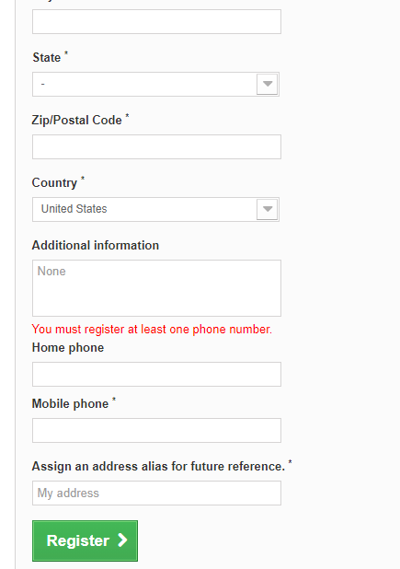  Failed to register successfully with error. Mandatory form must fill in.  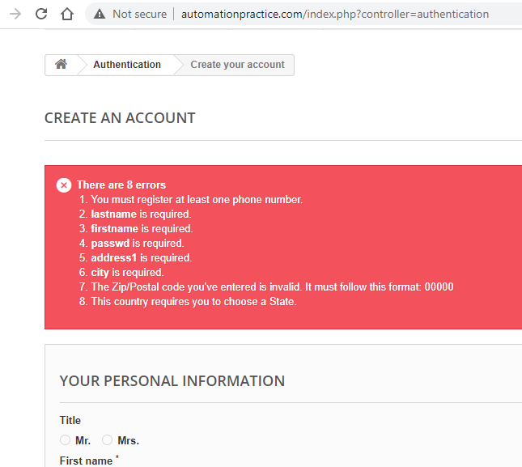

No | TC3
Function | Register
Input | Sign up with registered email
Scenario | - Sign In  - Create Account  - Register
Result | OK / Not OK
Capture | Click Sign In  Input Email for register, then hit Create an account  Register failed, success with error that email address already registered  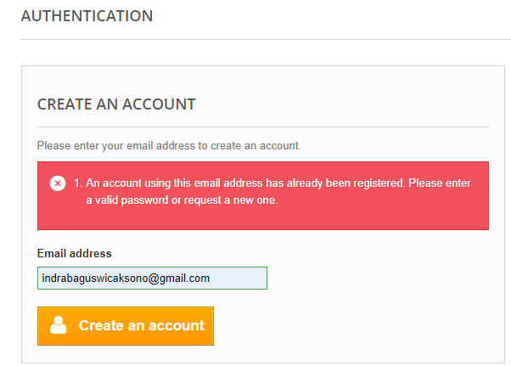

No | TC4
Function | Login
Input | Login with registered email
Scenario | - Sign in  - Sign in
Result | OK / Not OK
Capture | Click Sign In  Input Email and Password, then hit sign in  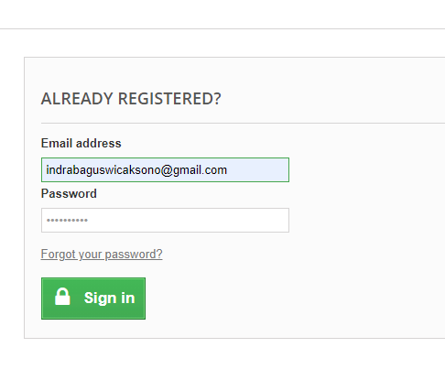  Login successfully  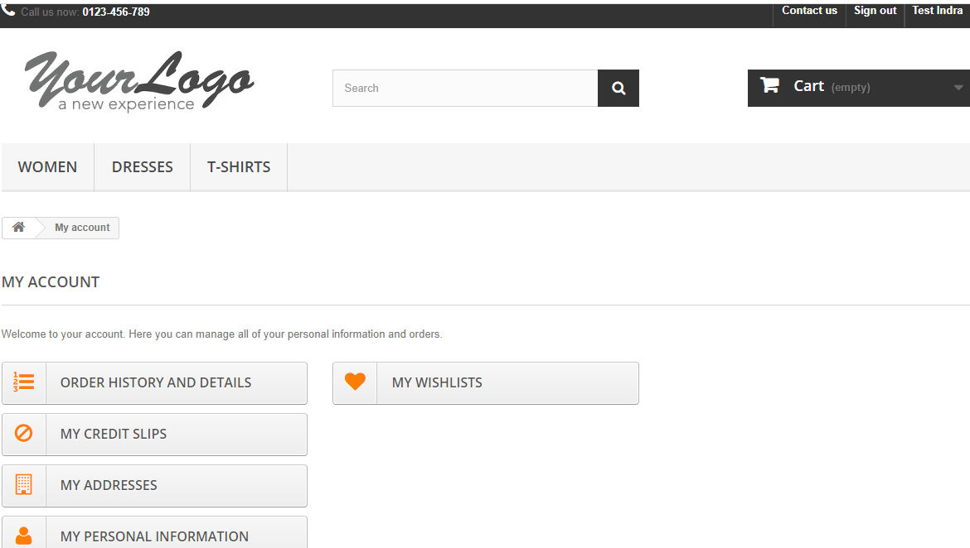

No | TC5
Function | Login
Input | Login with registered email
Scenario | - Sign in  - Sign in
Result | OK / Not OK
Capture | Click Sign In  Input unregistered Email and Password, then hit sign in  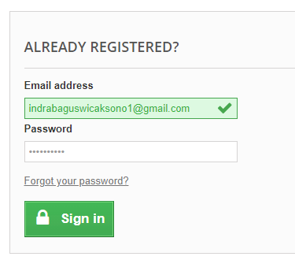  Failed login with error Authentication failed  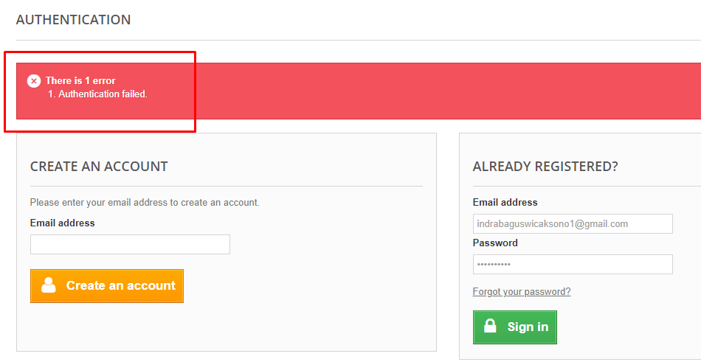

No | TC6
Function | Sign Out
Input | Sign Out
Scenario | - Sign Out
Result | OK / Not OK
Capture | Click Sign Out  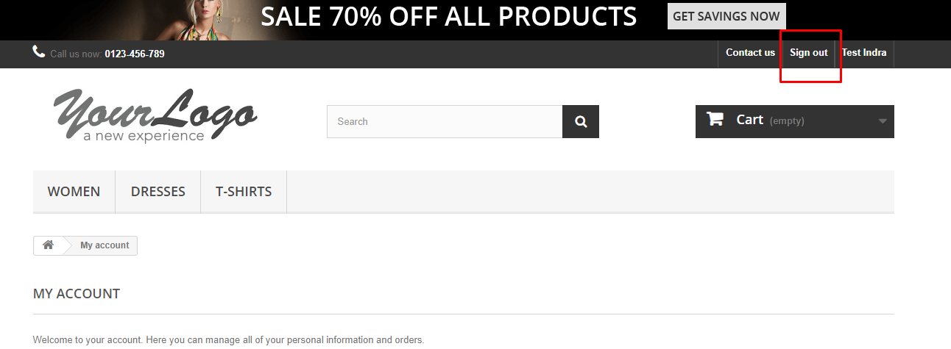  Sign out successfully  

